Name ____________________ Class _____ Date __________

Retail Buyer Job
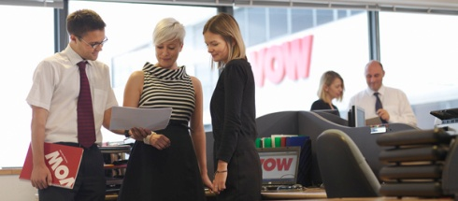
Directions: First, complete the Retail Buyer Job Comparison. Find 3 different Retail Buyers jobs at three different companies. Identify the type of store that is hiring (i.e. retail, department, boutique, etc.) Then list the duties of the Retail Buyer. Second, prepare a summary of your findings of how the job duties are different.
Retail Buyer Job Comparison

Job Title | Company | Type of Store | Duties
For example:  Assistant Buyer Ladies Apparel | Family Dollar | Discount | *develop competitive customer and market strategies  *create/select ads and endcaps for stores  *Shop local Family Dollar stores, as well as other comparative retail stores, on a regular basis to identify new trends and opportunities, evaluate merchandise mix, evaluate competition, and translate findings into executable product plans

Summarize how the duties are different
________________________________________________________________________________________________________________________________________________________________________________________________________________________________________________________________________________________________________________________________________________________________
________________________________________________________________________________________________________________________________________________________________________________

